AI FIT TRACK

TEAM ID

SWTID-2026-6879

TEAM LEADER

RAMYA .K (C24UG152CSC062)

TEAM MEMBERS

RAKSHITHA K (C24UG152CSC061)

MADHU N (C24UG152CSC039)

LAVANYA N (C24UG152CSC036)

PROJECT OVERVIEW – AI FIT TRACK
AI FitTrack is a secure, scalable, and AI-powered fitness management system developed to simplify workout tracking and provide personalized fitness guidance. The system uses Node.js, Express.js, MongoDB, Mongoose, JWT, bcrypt.js, and Google Gemini AI to manage workout records securely and generate intelligent fitness recommendations.
Key Features
- User Registration – Allows users to create a secure fitness account.
- Secure Login – Authenticates users using email and password.
- JWT Authentication – Protects sensitive APIs and personal workout data.
- Workout Management – Enables users to add, view, update, and delete workout records.
- Workout Search – Allows searching workouts by name, category, or date.
- AI Workout Recommendations – Generates personalized workout plans using Google Gemini AI.
- AI Fitness Insights – Analyzes workout statistics and provides useful fitness insights.
- MongoDB Database – Securely stores user and workout information.
- MVC Architecture – Provides a modular and maintainable project structure.
- Validation and Error Handling – Provides input validation, protected routes, centralized error handling, and standardized JSON responses.
3. Overall Workflow
User Registration → Login & JWT Authentication → Workout Management → MongoDB Storage → Workout Search & Statistics → Google Gemini AI Processing → Personalized Recommendations & Fitness Insights → JSON Response
4. Expected Outcome
AI FitTrack provides a secure and centralized platform for managing workout records while reducing manual fitness tracking.
The system uses AI to generate personalized workout recommendations and fitness insights based on user information and workout statistics.
Software Requirements

- Node.js (v16 or above): Runtime ecosystem running server logic and routing infrastructure.
- npm (v8 or above): Node package manager to control operational dependencies.
- Express.js: Lightweight routing web framework to construct backend RESTful entry points.
- MongoDB: Document NoSQL engine storing users, posts, categories, comments, and analytics metrics.
- Postman: API verification toolkit to assert schema validation responses across administrative route shields.
- Code Editor: Visual Studio Code or similar IDE environment.

2. Hardware Requirements
- Processor: Intel Core i5 (8th Gen or above) / AMD Ryzen 5 or equivalent.
- RAM: 8 GB minimum (16 GB recommended for concurrent instances of MongoDB, processing layers, and execution nodes).
- Storage: 1 GB of available disk workspace.

EPIC:PROJECT ARCHITECTURE

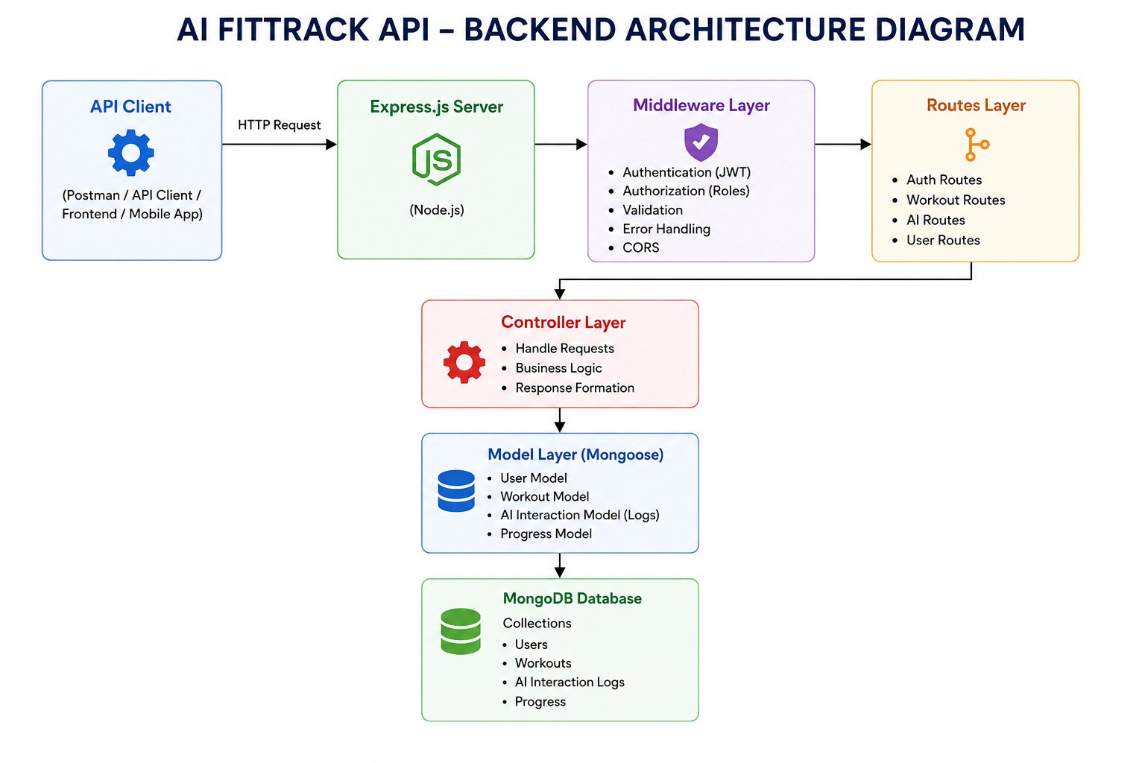
The FitTrack AI follows a layered architecture based on the MVC (Model–View–Controller) design pattern. The application separates routing, business logic, database interaction, middleware, and AI services into independent modules, making the project easier to maintain and scale.
COMPONENTS
- Client Layer – Sends HTTP requests and receives JSON responses through React, mobile applications, or Postman.
- Express Server – Acts as the main gateway, handles requests, middleware, CORS, and API routing.
- Authentication & Route Layer – Manages API endpoints and validates JWT tokens to protect secured resources.
- Controller & Service Layer – Processes requests, handles business logic, and communicates with AI services.
- Google Gemini AI Service – Generates personalized workout recommendations and fitness insights based on user data.
- Database Layer – Uses Mongoose models to store and retrieve user and workout data from MongoDB securely.
- Entity Relationship (ER) Diagram Description
The AI FitTrack backend consists of two primary collections that are logically connected through a one-to-many relationship.
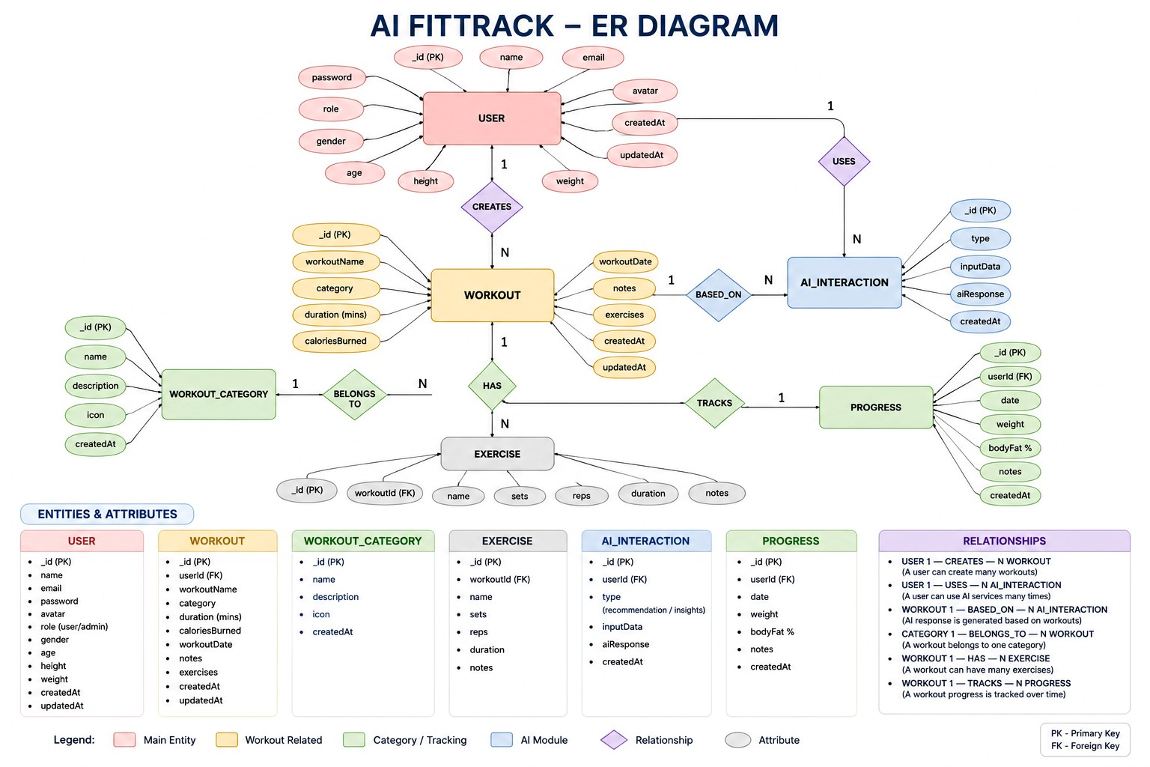

AI FIT TRACK – DATABASE,FEATURES & USER FLOW
Database Entity
- User Entity stores user authentication and profile information.
- Workout Entity stores workout details such as name, category, duration, and calories burned.
- Each User is identified using a unique ObjectId.
- Each Workout is linked to a User through the user ObjectId.
- User passwords are securely encrypted using bcrypt.
- The database maintains createdAt and updatedAt timestamps.
Key Relationships
- The main relationship is between User and Workout.
- The relationship type is One-to-Many.
- One User can create multiple Workout records.
- Each Workout belongs to only one User.
- The relationship is maintained using the user field in the Workout schema.
- This ensures that users can access and manage their own workout records.
Key Features
- Provides secure JWT-based user authentication.
- Supports complete workout CRUD operations.
- Allows users to search and manage workout history.
- Integrates Google Gemini AI for workout recommendations.
- Provides AI-based fitness insights and progress analysis.
- Uses RESTful APIs, centralized error handling, and modular architecture.
Roles
Authenticated User – registers, logs in, manages workouts, and views profile information.
The user can also request AI workout recommendations and fitness insights.
User Flow
Register/Login → JWT Authentication → View Profile → Add/View/Search/Update/Delete Workouts.
Workout Data → Gemini AI → Recommendations & Fitness Insights → User.

User Flow
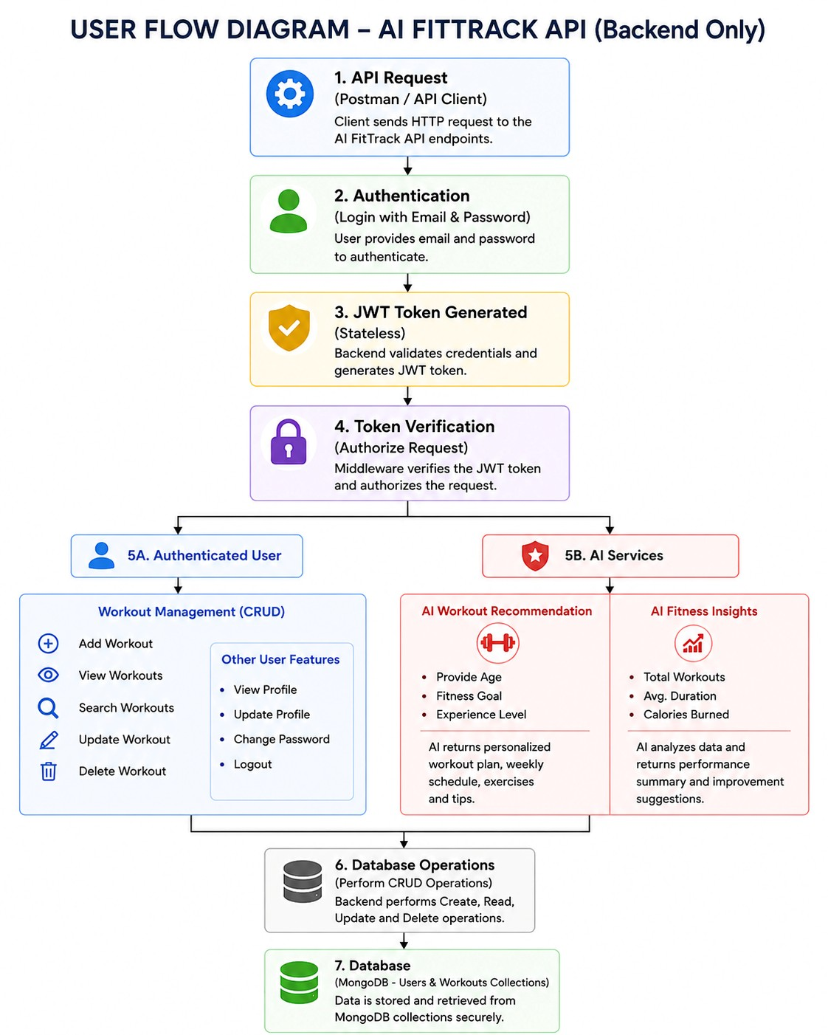

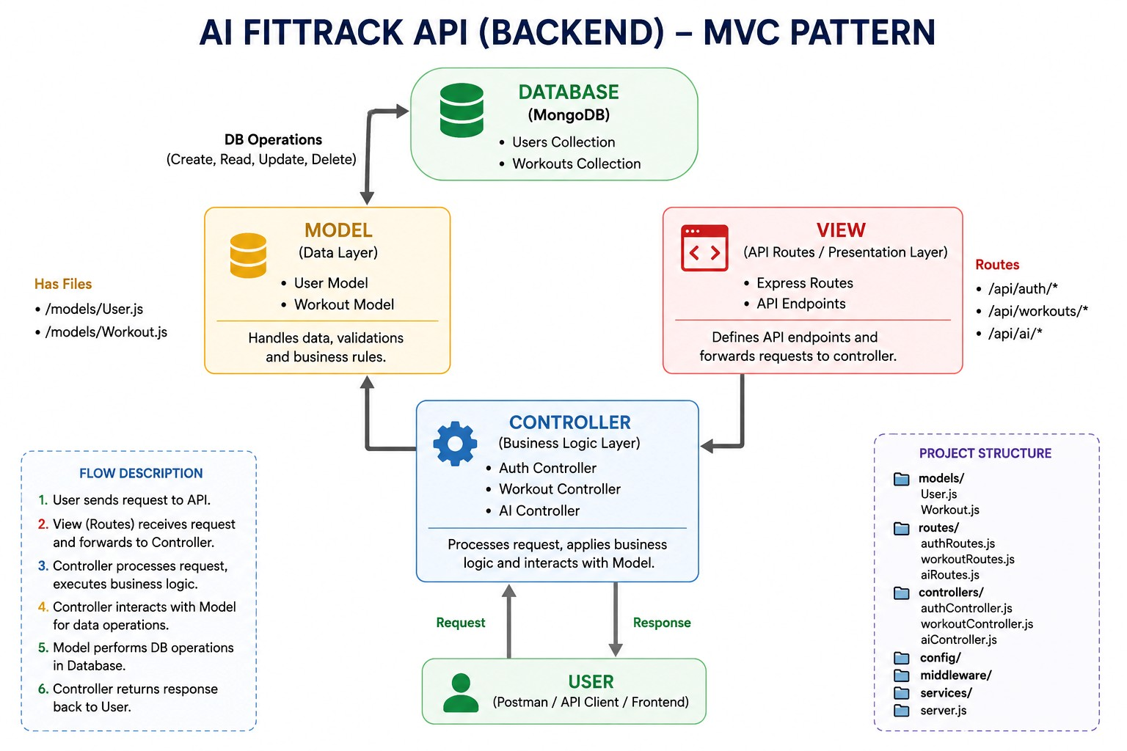 AI FITTRACK – MVC ARCHITECTURE
- Model Layer – Defines User and Workout schemas and communicates with MongoDB.
- View Layer – Represents API consumers such as React, mobile apps, or Postman.
- Controller Layer – Handles requests, business logic, validation, and responses.
- The three layers provide separation of concerns, making the system modular and maintainable.
Benefits
- Improves code readability and organization.
- Makes the application easier to test and debug.
- Provides better maintainability and scalability.
- Allows new features to be added without affecting existing modules.
Project Setup and Configuration
- The backend is developed using Node.js and Express.js.
- MongoDB is used for database management through Mongoose.
- Google Gemini AI is integrated for intelligent fitness recommendations.
Project Initialization
- Create the project folder named AI-FitTrack-API.
- Open the project folder in Visual Studio Code.
- Create a server folder for backend source code.
- Open the terminal inside the server folder.
- Run npm init -y to create the package.json file.
- Install required packages such as Express, Mongoose, dotenv, bcryptjs, JWT, CORS, and Nodemon.
Create the Following Files
- server.js – Main entry point of the backend application.
- .env – Stores environment variables and sensitive configuration.
- package.json – Contains project information and dependencies.
- README.md – Provides project documentation and setup instructions.
Create the Following Folder Structure
AI-FitTrack-API/
│
└── server/
├── config/
├── controllers/
├── middleware/
├── models/
├── routes/
├── services/
├── .env
├── server.js
└── package.json
Environment Development
- Install Node.js and Visual Studio Code.
- Create the AI-FitTrack-API project folder.
- Initialize the Node.js project using npm init -y.
- Configure PORT, MONGO_URI, JWT_SECRET, and GEMINI_API_KEY in the .env file.
- Use environment variables to keep sensitive information separate from the source code.
Backend Development
- Develop the backend using Node.js and Express.js to create RESTful APIs.
- Connect the application to MongoDB using Mongoose for storing user and workout data.
- Implement JWT authentication, password encryption, and CRUD operations for secure workout management.
- Integrate Google Gemini AI to provide personalized workout recommendations and fitness insights.

BACKEND STRUCTURE
AI-FitTrack-API/
│
└── server/
│
├── config/
│ └── db.js
│
├── controllers/
│ ├── authController.js
│ └── workoutController.js
│
├── middleware/
│ ├── authMiddleware.js
│ └── errorMiddleware.js
│
├── models/
│ ├── User.js
│ └── Workout.js
│
├── routes/
│ ├── authRoutes.js
│ └── workoutRoutes.js
│
├── services/
│ └── geminiService.js
│
├── .env
├── server.js
└── package.json
MONGODB CONFIGURATION
MongoDB stores application data in collections rather than traditional relational database tables. The FitTrack AI maintains separate collections for users and workouts.

Database Collections
- Users Collection
- Workouts Collection
Each collection stores JSON-like documents (BSON format), allowing flexible schema design while maintaining efficient data retrieval.

Installing Mongoose
Install Mongoose using npm.
npm install mongoose
Mongoose acts as the bridge between the Node.js application and MongoDB by providing schema definitions, validation, and database methods.

MongoDB Connection
The database connection is configured inside the config/db.js file. This module establishes a connection to the MongoDB server when the application starts.
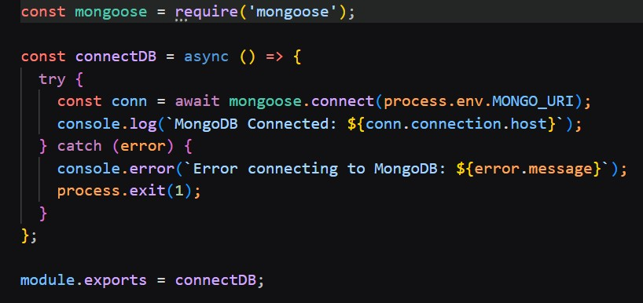

Responsibilities
- Connect to MongoDB
- Handle Connection Errors
- Display Connection Status
- Export Database Connection

Advantages
- Centralized database configuration
- Reusable connection module
- Automatic connection management
- Simplified error handling

Mongoose Schemas
The AI FitTrack backend contains two primary Mongoose schemas:
- User Schema
- Workout Schema
Schemas define the structure, validation rules, and relationships for MongoDB documents.

1. User Schema (models/User.js)
The User schema stores authentication information for registered users.
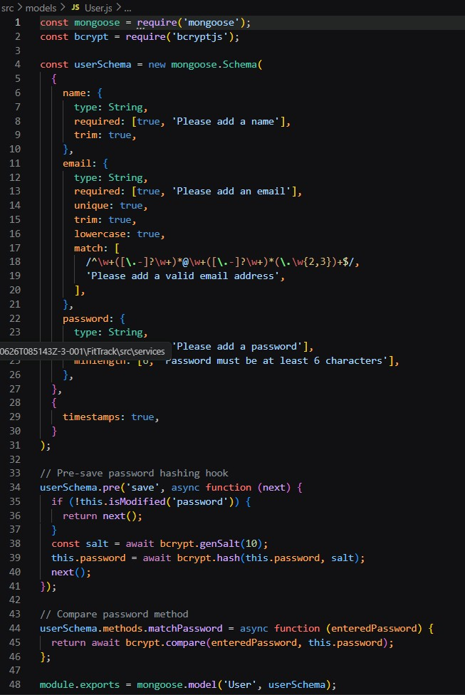

Validation Rules
- Name cannot be empty.
- Email must be unique.
- Password is mandatory.
- Password is encrypted using bcrypt.js before saving.
- Automatic timestamps are enabled.

User Schema Features
- Email uniqueness validation
- Password hashing
- Automatic timestamps
- Secure authentication support
- JWT integration

2. Workout Schema (models/Workout.js)
The Workout schema stores workout information created by authenticated users.
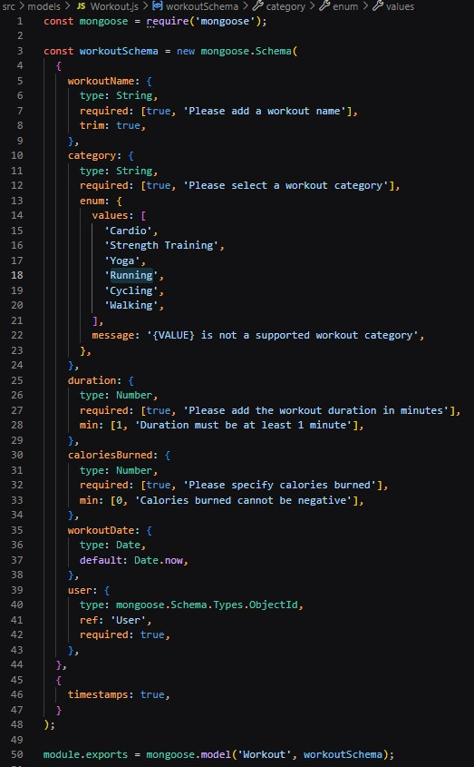

Validation Rules
- Workout Name is mandatory.
- Category is mandatory.
- Duration must be greater than zero.
- Calories Burned must be greater than or equal to zero.
- Workout Date is required.
- Every workout belongs to one authenticated user.

Workout Schema Features
- Schema validation
- Automatic timestamps
- User relationship
- Easy search support
- Efficient CRUD operation

API Testing
API testing ensures that every endpoint functions correctly and returns the expected response. The FitTrack AI is tested using Postman, allowing developers to verify request handling, authentication, database operations, and AI integration.
Testing is performed in the following order:
- Authentication APIs
- Workout APIs
- AI APIs

Authentication API Testing

Register User
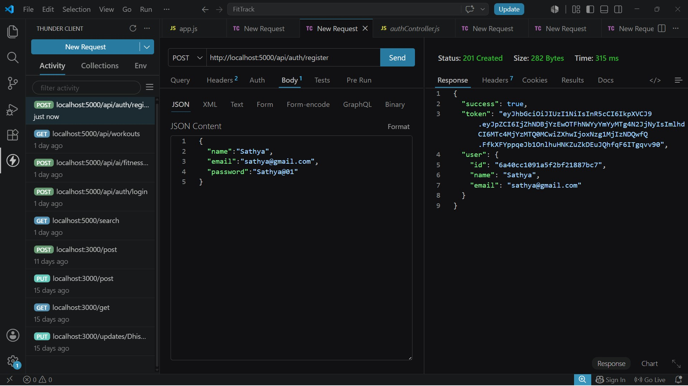

Login User
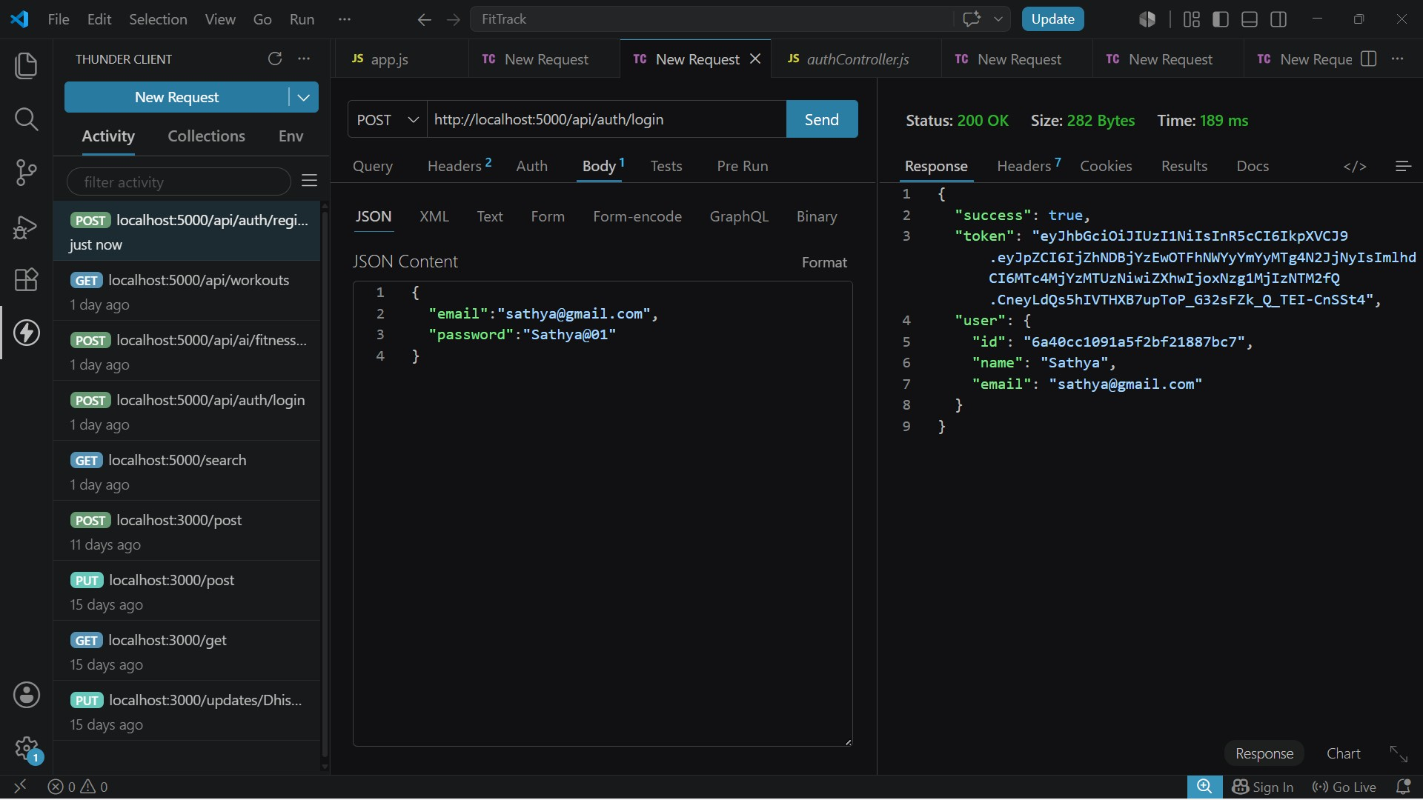

Get Profile
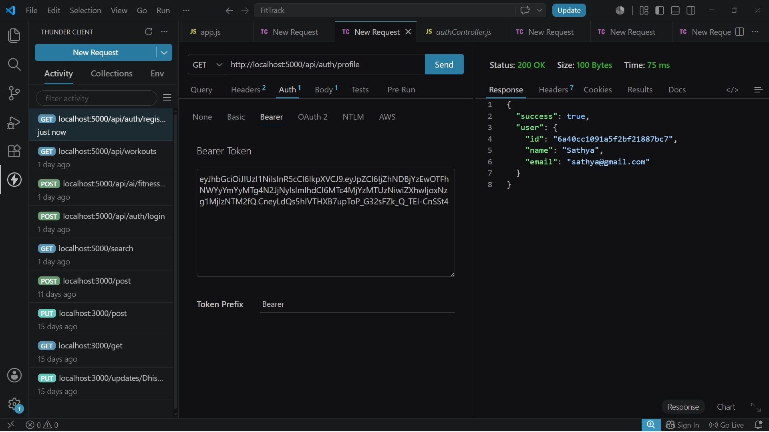

Workout API Testing

Add Workout
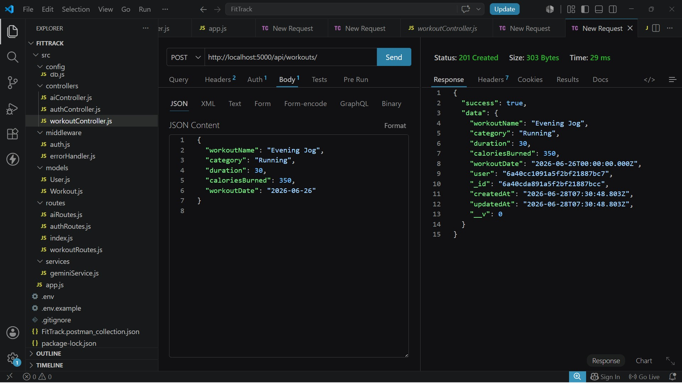

Get All Workouts
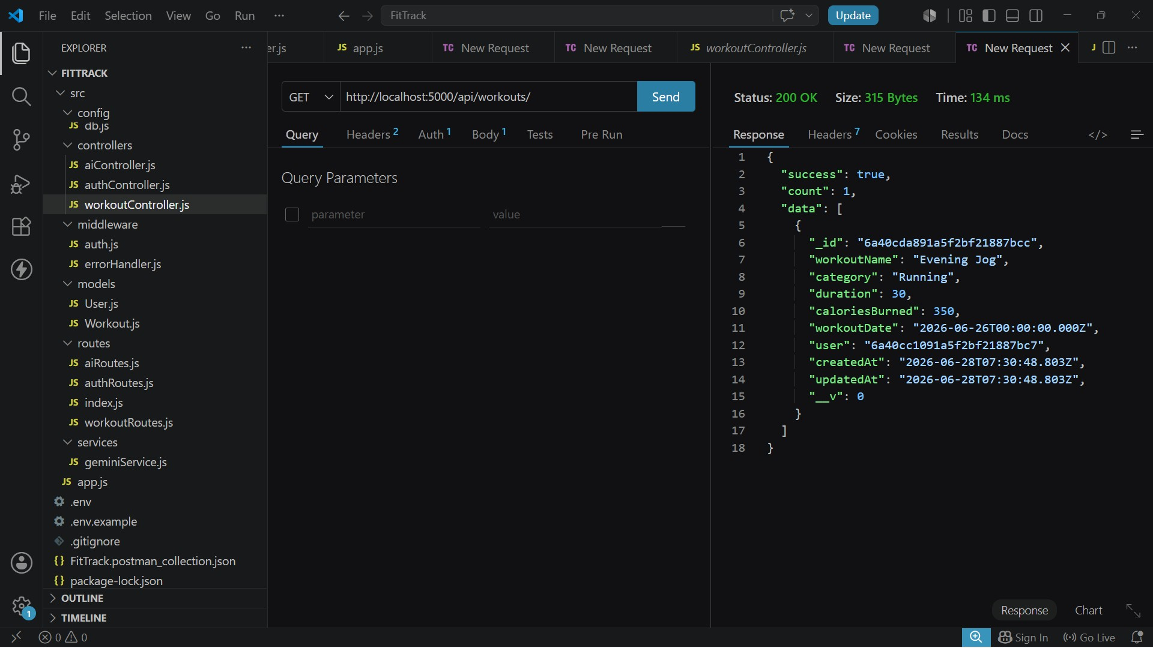

Get Workout By ID
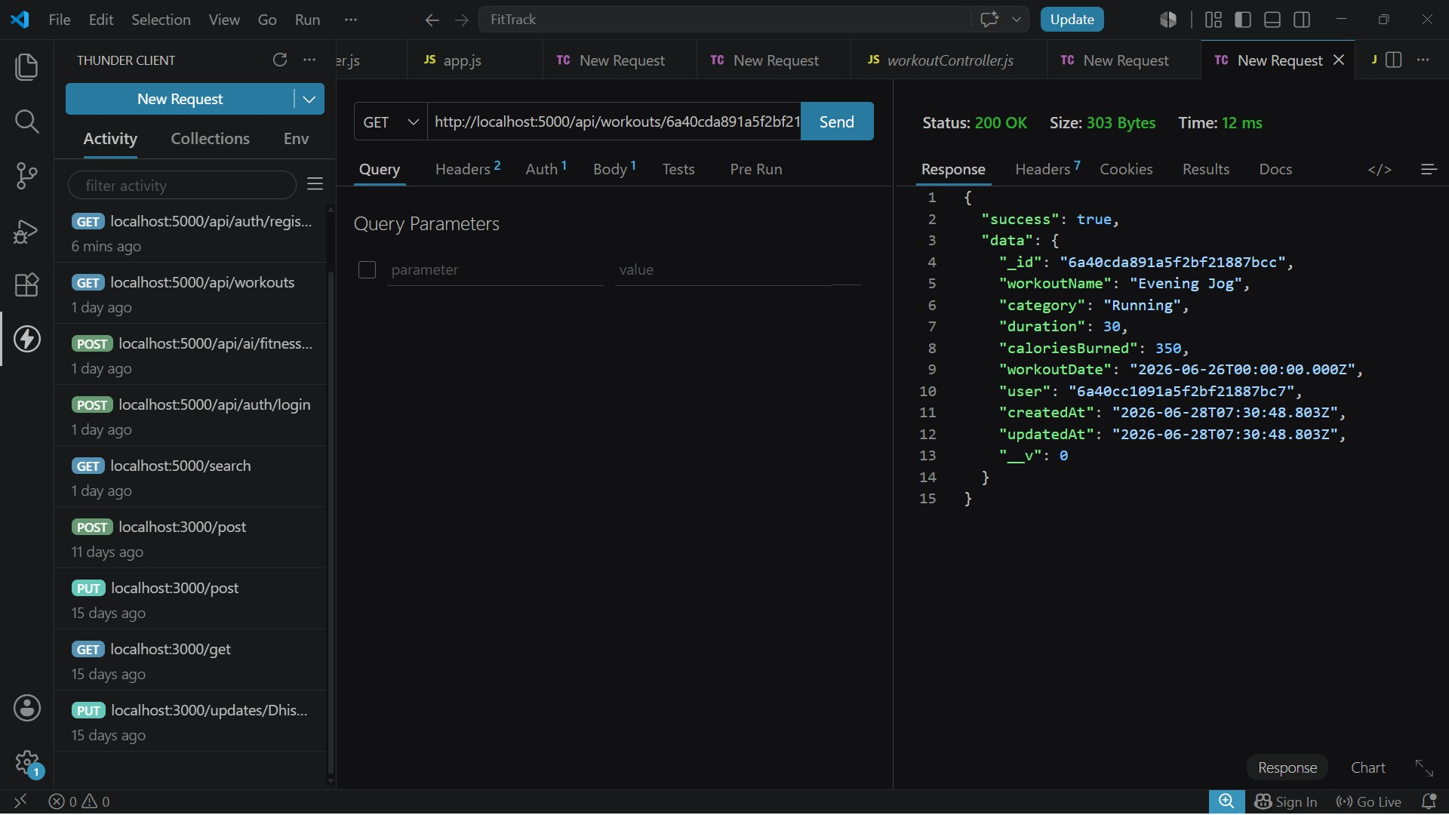

Update Workout
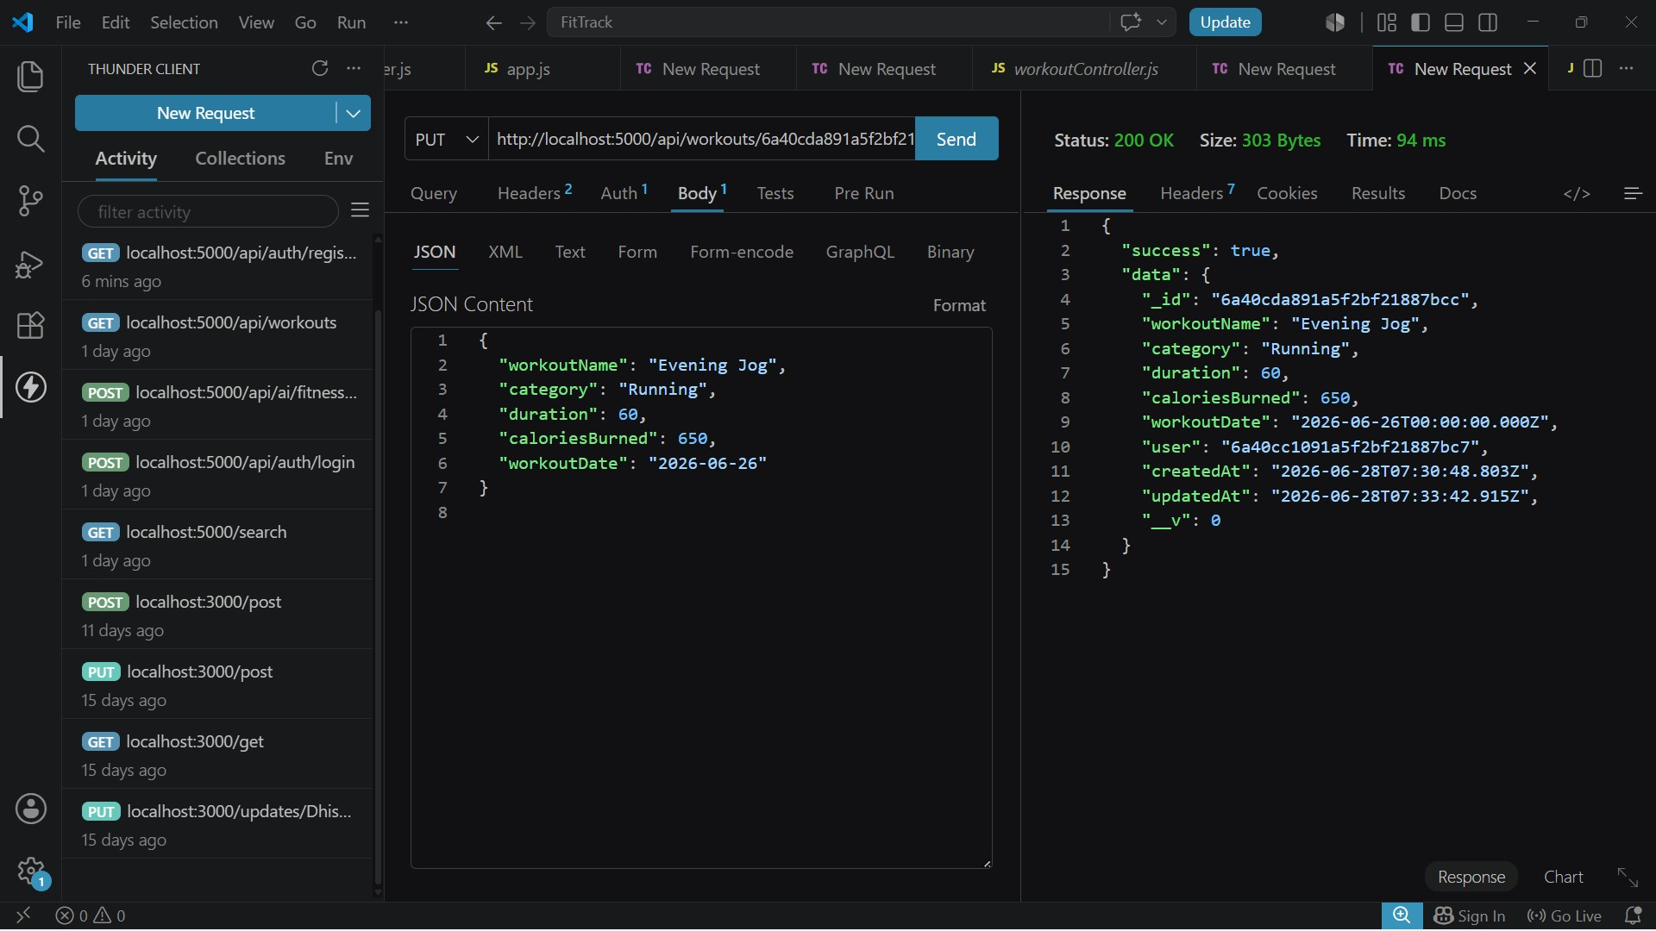

Delete Workout
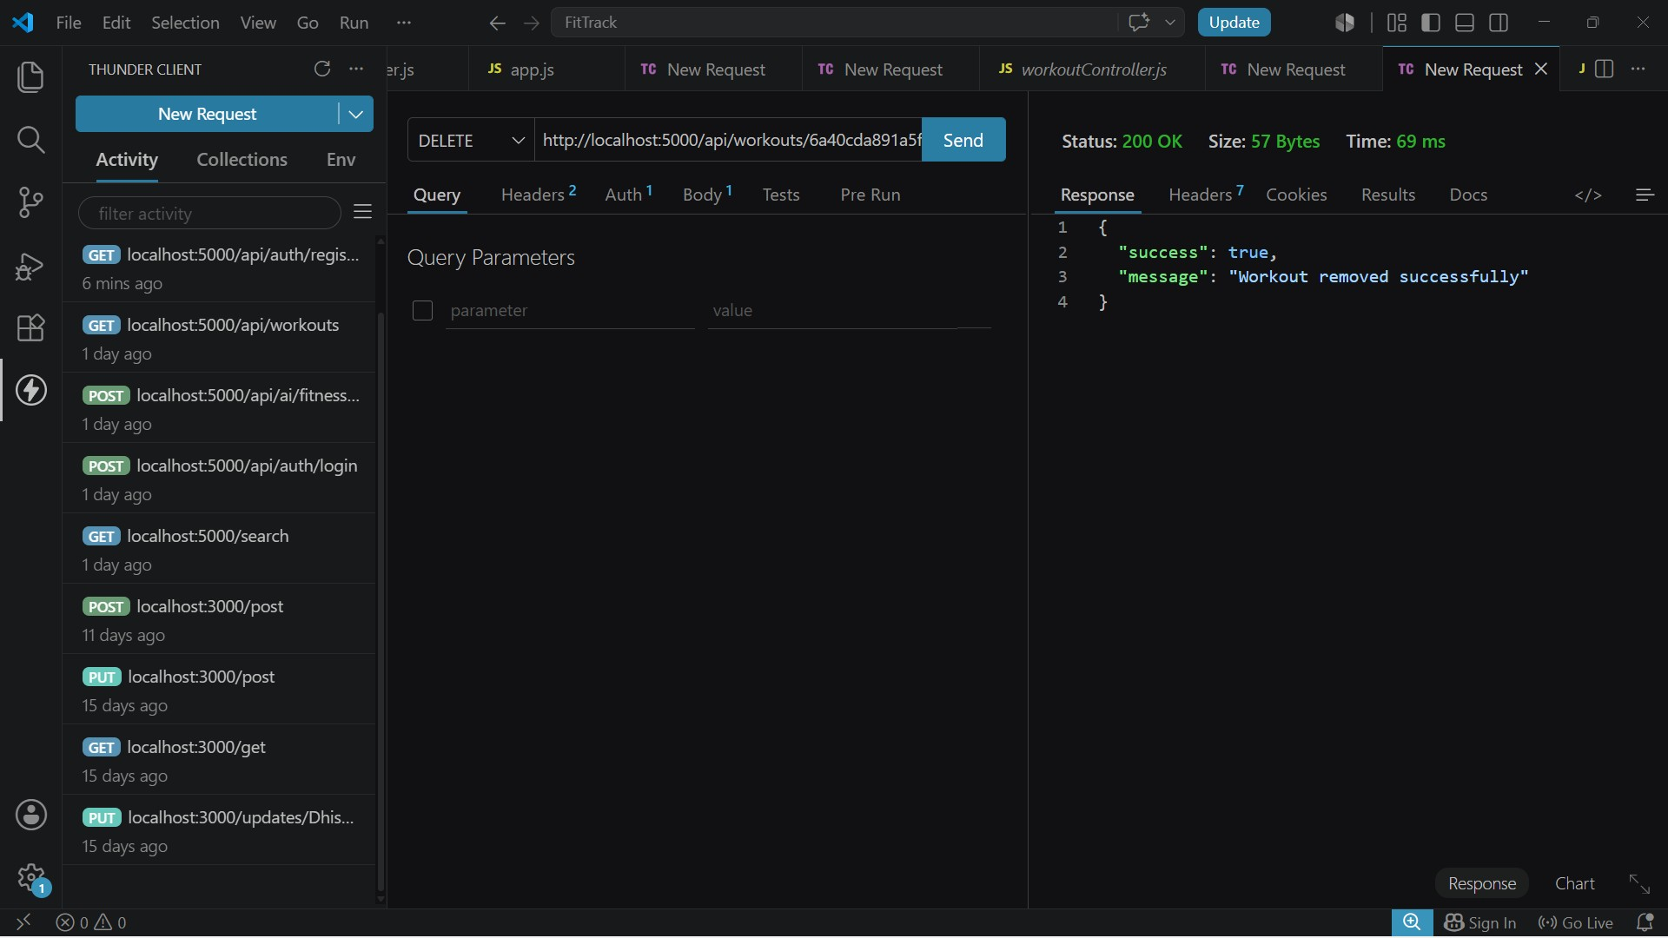

AI API Testing

Workout Recommendation
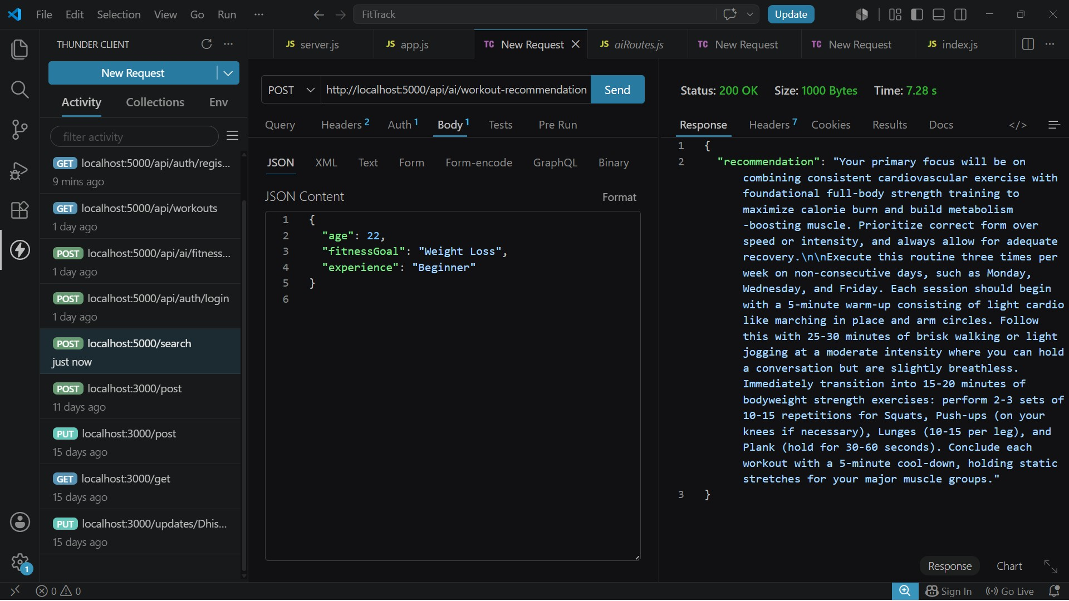

Fitness Insights
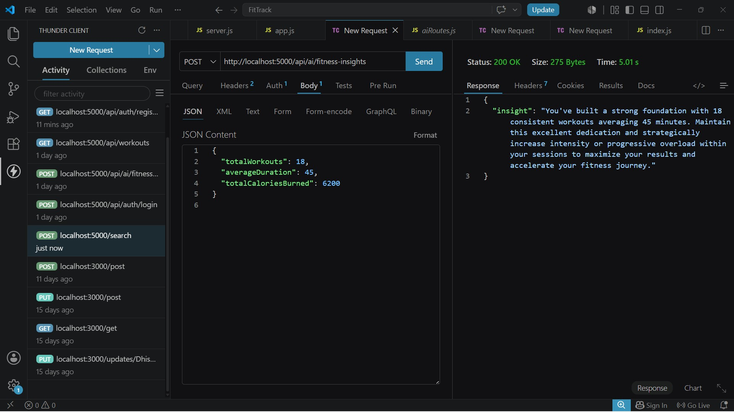
Demo Video Link:
https://drive.google.com/file/d/11xs5MjNrZAbt9toUtpLDynoaOP2_TiVF/view?usp=drive_link
CodeDrive: https://drive.google.com/file/d/1Vy4qCJG-byFx0V_Pz alHDh_jiO5P1Z2/view?usp=drive_link

